FRONT PAGE
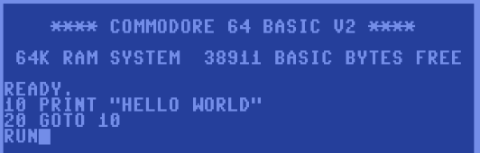
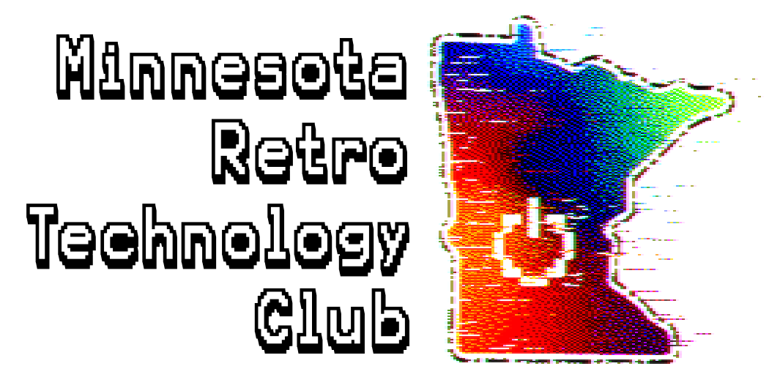
We are a community of enthusiasts, collectors, and tinkerers who love vintage computers, audiovisual equipment, telephony, and other electronic technologies of yesteryear!

Our goal is to connect people within the Twin Cities and greater Minnesota area to share our passion and knowledge, as well as preserve computing history for future generations to enjoy.

Click on the links to the left to learn more and get involved!

WHY VINTAGE COMPUTERS?

In the modern day, computers have become ubiquitous and heavily integrated into everyday life. Our home appliances and vehicles have computers inside them. Our entertainment is delivered to us on computers via the Internet. We carry miniaturized computers in our pockets. Stores, public transportation, and many businesses rely on computers to process our money and staggering amounts of data. Unfortunately, that means we often take them for granted until disaster strikes. Many people don’t know how they work, or why they are made the way they are!

There is also the problem of so-called “enshittification.” As the corporations that run our digital world become more huge and unsustainable, they find new ways to nickel-and-dime the everyday user, making our experience worse in the name of profit and “progress.”

There is a growing desire to return to the past, to a time when the computer was a simple appliance, enshrined on a dedicated desk in our home. When connecting to the Internet was a time-consuming luxury, and the websites we visited were text-based and straight to the point. Computer programs were a means to an end, rather than a constant battle for our attention and our money. Limitations bred creativity.

